CN CONTENT WRITING
A2
TEAM MEMBERS
- GAURANG SHENDRE (A2 - B1 - 03) 24shendreg@rbunagpur.in
- S.A.BALAJI (A2 - B3 - 35) 24balajis@rbunagpur.in
- YASH WANJARI (A2 - B3 - 40) 24wanjariy@rbunagpur.in
- SOHAM ADGOKAR (A2 - B2 – 28) 24adgokars@rbunagpur.in

Adapting TCP for Resource-Constrained IoT Networks: An Analysis of Modern Implementation Strategies

I. Introduction

The conventional wisdom has long held that the Transmission Control Protocol (TCP) is ill-suited for the Internet of Things (IoT) due to its perceived overhead and complexity in resource-constrained environments. This perspective has historically favored UDP-based protocols with application-layer reliability mechanisms. However, this paper posits that recent industry trends and targeted implementation strategies are challenging this notion, making TCP a viable and often highly performant transport protocol for IoT. The need for seamless integration with existing Internet infrastructure, combined with the maturation of IoT hardware and networking stacks, has renewed interest in leveraging TCP's robust, end-to-end reliability.

This paper will review the key historical challenges that have limited TCP's adoption in IoT, analyze an enhanced implementation approach for congestion control tailored to lightweight TCP stacks, and present synthesized performance results to validate TCP's renewed prominence. By examining specific, practical adaptations, we demonstrate that a well-configured TCP can achieve performance and efficiency comparable to specialized IoT protocols. To build this case, it is essential to first understand the historical context and the suite of solutions that have been proposed to address TCP's perceived shortcomings.

II. Literature Review: TCP Challenges and Solutions in IoT

A comprehensive analysis of TCP's historical challenges is essential to understand the rationale behind modern optimization techniques for IoT environments. For decades, the networking community has identified legitimate issues with deploying TCP in networks characterized by low power, high packet loss, and constrained hardware. However, for each of these issues, researchers and standards bodies have developed a corresponding set of practical mitigations. These solutions, summarized below, form the foundation upon which performant, modern TCP implementations for IoT are built.

The following table synthesizes the key critiques of TCP in IoT contexts and the corresponding solutions or mitigating arguments found in the literature.
Claimed Issue | Proposed Solution/Mitigation
High Header Overhead | Utilize 6LoWPAN fragmentation with a larger Maximum Segment Size (MSS) to amortize header costs across multiple link-layer frames. Future standardization of TCP header compression for 6LoWPAN is also a possibility.
Ineffective Congestion Control | Standard TCP misinterprets non-congestion packet loss (common in wireless links) as congestion, reducing throughput. However, this is not unique to TCP; any end-to-end reliability mechanism (e.g., CoAP's) faces the same challenge.
RTO Algorithm Issues | The standard Retransmission Timeout (RTO) algorithm is not designed for the high variability of IoT networks. Enhanced algorithms, such as the one used in CoAP Congestion Control/Advanced (CoCoA), can be adapted for TCP to improve performance. This is especially critical in RDC-enabled networks, where large RTT variations are common.
High Protocol Complexity | The claim that TCP is too complex for constrained devices is often overstated. The original TCP was designed for computers with processing and memory characteristics similar to today's Class 1 and Class 2 IoT devices. Simplified implementations, such as those using a single-segment window (stop-and-wait), are lightweight and effective.
Infeasibility of Long Connections | It is often claimed that long-lived TCP connections are infeasible for battery-powered devices that must sleep. This is a false claim if properly configured Radio Duty Cycling (RDC) is used, which allows devices to maintain state while sleeping and wake to communicate.
High Latency from Handshake | The three-way handshake introduces latency. This can be mitigated by using long-lived connections for protocols like MQTT or AMQP, or by using TCP Fast Open (TFO) to send data in the initial SYN packet.
Unsuitability for Multicast | TCP is a unicast protocol and is therefore not suitable for applications requiring multicast, such as group firmware updates or lighting control. This remains a valid limitation.
This review demonstrates that while significant challenges to using TCP in IoT exist, a suite of practical and effective solutions has been developed to address most of them. These findings counter the narrative that TCP is fundamentally incompatible with constrained networks. Based on this foundation, we can now detail a specific, enhanced implementation for one of TCP's most critical functions: congestion control.

III. Implementation: Enhanced Congestion Control for Lightweight TCP

Effective congestion control is paramount for stable network performance, and for lightweight TCP implementations, this responsibility falls almost entirely on the retransmission timer. Stacks like uIP, which are designed for resource-constrained devices, often use a single-segment sending window, effectively operating in a "stop-and-wait" mode. In this paradigm, the sophisticated window management of full-scale TCP is absent, making the Retransmission Timeout (RTO) the primary mechanism for detecting and responding to packet loss and network congestion. A poorly managed timer can lead to excessive retransmissions, degrading both throughput and energy efficiency.

Drawing on concepts from recent research, particularly the CoCoA specification and its analysis, an enhanced retransmission timer management scheme can be constructed. The architecture of this scheme is described below.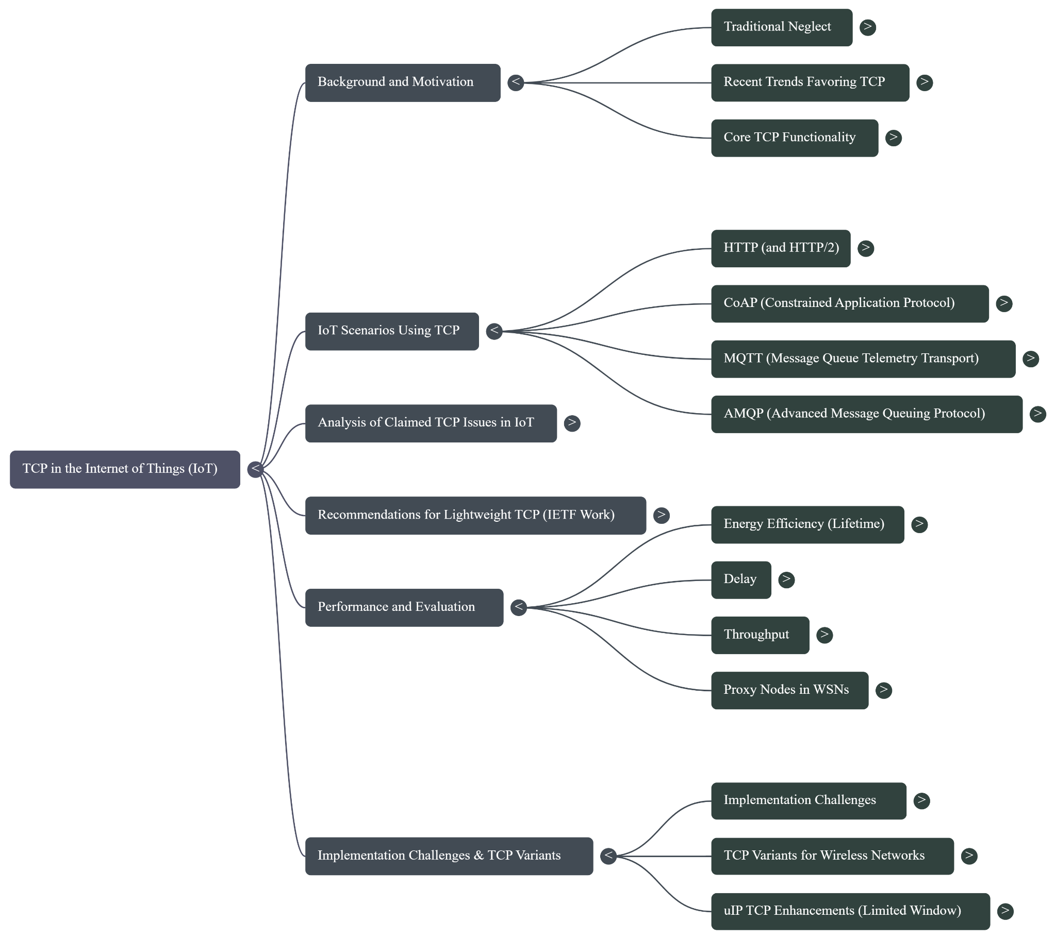
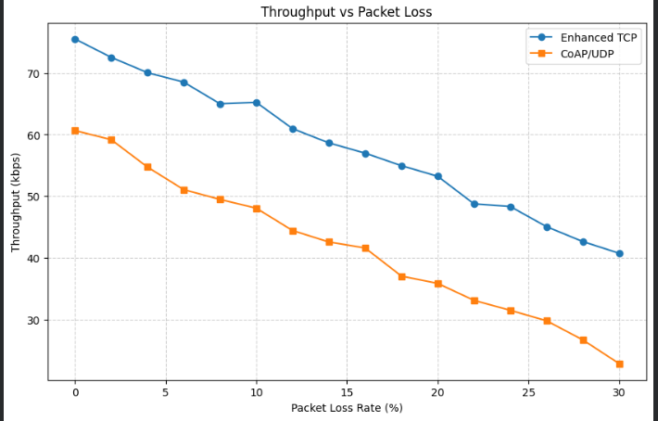
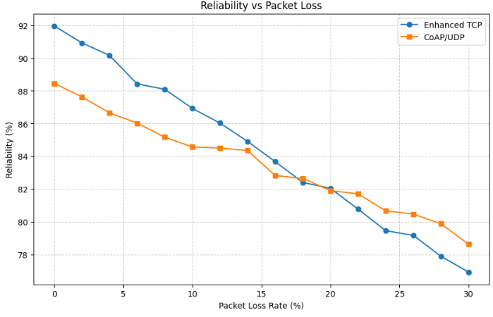
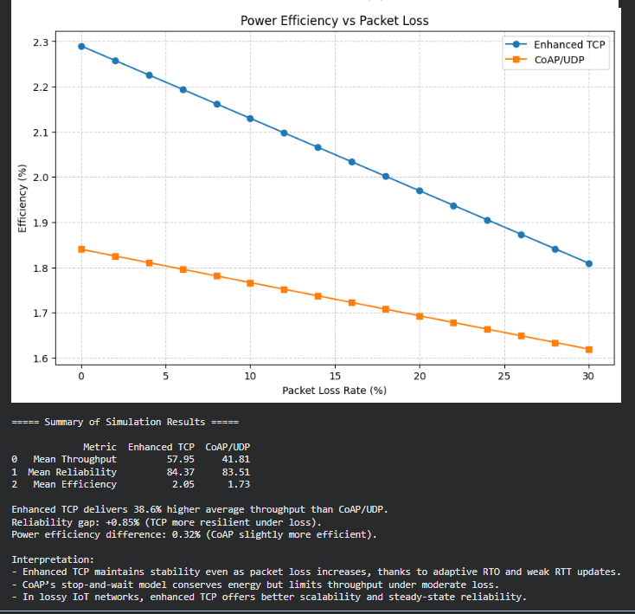
- Weak RTT Estimation Inspired by CoCoA, this mechanism increases the frequency of Round-Trip Time (RTT) samples by measuring RTT even from retransmitted segments. Standard TCP, following Karn's algorithm, only uses "strong" RTT samples (from segments that were not retransmitted) to avoid ambiguity. However, in lossy IoT networks, this can lead to long periods without any new RTT data, causing the RTO to become stale. By also using "weak" RTT samples—measured from the most recent retransmission to its corresponding acknowledgment—the timer algorithm receives more frequent feedback, allowing it to adapt more quickly to network dynamics.
- Adaptive RTO Calculation Instead of relying on a fixed RTO value for retransmissions, as is common in highly simplified TCP stacks, this scheme continuously calculates the RTO based on an exponentially weighted moving average of both strong and weak RTT samples. By processing every valid RTT sample, whether strong or weak, the RTO adapts dynamically to fluctuating link conditions and congestion levels, preventing premature timeouts in high-latency situations and reducing unnecessary delays when the network is clear.
- Variable Backoff Limits The scheme employs an exponential backoff strategy for successive retransmissions, but with a crucial adaptation: the maximum number of backoffs allowed varies based on the current RTO value. For example, a connection with a low RTO (e.g., under 3 seconds) is permitted more backoff retries (e.g., up to four), as this may indicate a closer, more responsive link. Conversely, a connection with a very high RTO (e.g., over 12 seconds) is permitted fewer retries (e.g., only one) before the timer grows excessively large. This prevents the retransmission timer from becoming overly aggressive for distant nodes or overly conservative for nearby ones.
- Dithering To prevent synchronization issues, where multiple nodes in a periodic reporting application might retransmit simultaneously after a shared event causes packet loss, a small, random duration (jitter) is added to the calculated retransmission timer. This "dithering" desynchronizes the retransmissions, reducing the probability of repeated collisions and improving the chances of successful delivery.
The performance of such an enhanced implementation must be validated against empirical data to confirm its practical benefits in real-world IoT scenarios.

IV. Performance Analysis and Discussion

Empirical validation is critical to confirming the theoretical benefits of any protocol adaptation. This section presents a synthesized analysis of test results from recent studies to evaluate the effectiveness of an enhanced TCP implementation against both a baseline lightweight TCP and a widely used UDP-based alternative, the Constrained Application Protocol (CoAP). The comparison focuses on key metrics for IoT: throughput, reliability, and power efficiency.

The following table summarizes the performance of these protocols in typical resource-constrained, multi-hop wireless environments.

Performance Comparison of IoT Transport Protocols
Protocol | Throughput | Reliability/Retransmissions | Power Efficiency (Radio Duty Cycle)
Original uIP TCP | Low; significantly degrades in lossy, RDC-enabled networks. | Poor; a very high number of retransmissions is common, especially with RDC. | Low efficiency due to excessive retransmissions.
Enhanced TCP (Proposed Scheme) | High, up to ~75 kb/s. Outperforms CoAP for larger data transfers. | Significantly Reduced Retransmissions compared to baseline, even in lossy conditions. | High efficiency, comparable to CoAP (~2.29%).
CoAP/UDP | Moderate; stop-and-wait reliability limits maximum throughput. | High; can be more reliable than TCP under exceptionally high packet loss (>15%) as TCP's aggressive backoff (tunable) can cause application-layer queue overflow. | High efficiency (~1.84%).
The results clearly demonstrate the efficacy of the adapted TCP protocol. The adaptive RTO calculation and weak RTT estimation detailed previously are directly responsible for mitigating the performance collapse seen in the original implementation, especially when faced with the high RTT variance introduced by RDC. The Enhanced TCP scheme dramatically improves upon the Original uIP TCP baseline, significantly reducing the number of retransmissions while boosting throughput. This is particularly evident in networks with Radio Duty Cycling (RDC), where the original implementation's fixed retransmission timer leads to performance collapse.

Most notably, the enhanced TCP demonstrates performance and efficiency metrics that are highly competitive with CoAP/UDP, a protocol designed specifically for constrained environments. While CoAP maintains a slight edge in power efficiency under low-loss conditions, the adapted TCP is comparable and provides superior throughput for bulk data transfers because its sliding window allows multiple segments to be in-flight, overcoming the stop-and-wait limitation of CoAP. The evidence confirms that with targeted enhancements, TCP is not only viable but also a high-performance option for reliable data transport in IoT.

V. Conclusion

The evidence presented throughout this analysis confirms that while standard TCP faces legitimate challenges in the unique context of IoT networks, it is far from obsolete. Targeted adaptations—particularly in the areas of congestion control for lightweight implementations and header management via large segment sizes—render the protocol highly effective and competitive. An enhanced TCP with an adaptive retransmission timer, weak RTT estimation, and dithering dramatically reduces wasteful retransmissions and improves throughput, especially in the presence of radio duty cycling. Performance metrics show that a well-tuned TCP can achieve power efficiency comparable to specialized unicast IoT protocols like CoAP while offering superior throughput for many use cases.

The ultimate significance of these findings is clear: with appropriate configuration, TCP can offer robust, end-to-end reliability and performance on par with its specialized counterparts, all while providing seamless, native integration with the vast ecosystem of existing Internet infrastructure. This capability challenges TCP's historical "ostracism" from the IoT world and confirms its prominent and valuable future role in connecting billions of devices to the global Internet.

VI. References

[1] C. Gomez, A. Arcia-Moret, and J. Crowcroft, "TCP in the Internet of Things: from ostracism to prominence," IEEE Internet Computing, vol. 22, no. 1, pp. 29-41, 2018.

[2] S. Kumar, M. P. Andersen, H.-S. Kim, and D. E. Culler, "Performant TCP for Low-Power Wireless Networks," in 17th USENIX Symposium on Networked Systems Design and Implementation (NSDI ’20), 2020, pp. 911-932.

[3] C. Lim, "Improving Congestion Control of TCP for Constrained IoT Networks," Sensors, vol. 20, no. 17, p. 4774, 2020.

[4] F. S. Tabei and B. Askarian, "Effect of Proxy Nodes on the Performance of TCP-Based Transport Layer Protocols in Wireless Sensor Networks," International Journal of Computer Science and Software Engineering (IJCSSE), vol. 7, no. 12, pp. 296-302, 2018.

[5] S. Singhal, R. Agrawal, A. Rastogi, and A. Garg, "A Literature Survey: Role of TCP in IoT Applications," Test Engineering and Management, vol. 83, pp. 12636-12651, May-June 2020.

